Scada Transformer Dashboard Vue Quasar

SCADA Transformer Dashboard — Vue.js + Quasar

Overview
This SCADA dashboard is designed for real-time transformer monitoring within the Smart Grid Digital Twin platform.
The dashboard visualizes:
- Electrical telemetry
- Thermal monitoring
- Oil & gas diagnostics
- Transformer health score
- Predictive maintenance indicators
- Alarm states
- AI forecasting
- Realtime sensor analytics
The design follows modern industrial SCADA principles:
- Dark industrial UI
- Realtime updates
- GIS-ready integration
- Operator-friendly visualization
- Alarm prioritization
- Digital Twin awareness

Dashboard Layout
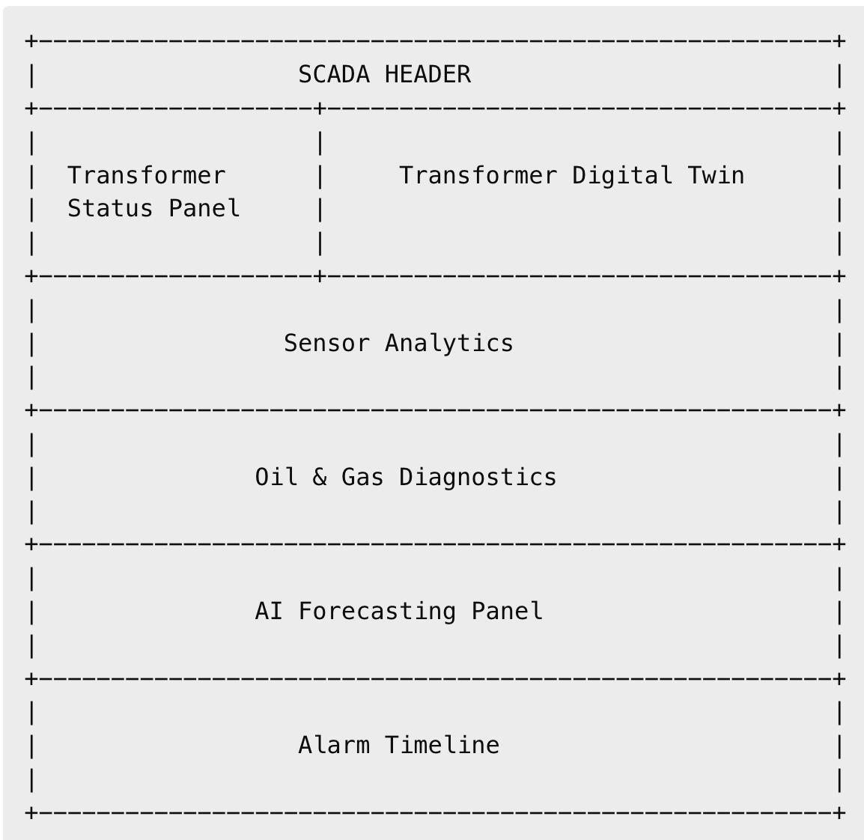

Technologies Used

Frontend
- Vue.js
- Quasar Framework
- ECharts
- WebSockets
- Leaflet (optional GIS integration)

Backend Integration
- FastAPI
- Socket.IO
- CrateDB
- EMQX

Transformer Sensors

Electrical Sensors

Voltage
- High voltage monitoring
- Voltage stability
- Voltage imbalance

Current
- Transformer load current
- Overload detection
- Phase imbalance

Frequency
- Grid frequency stability
- Frequency anomalies

Active Power
- Real-time power transfer
- Consumption analytics

Reactive Power
- Reactive compensation monitoring
- Grid balancing

Harmonics (THD)
- Power quality monitoring
- Harmonic distortion detection

Thermal Sensors

Oil Temperature
- Transformer oil thermal state
- Overheating detection

Winding Temperature
- Internal transformer stress
- Thermal degradation monitoring

Busbar Temperature
- Connection overheating detection

Ambient Temperature
- Environmental conditions
- Cooling efficiency analysis

Oil & Gas Monitoring

Oil Level
- Oil volume monitoring
- Leakage detection

Oil Pressure
- Pressure abnormalities
- Internal stress indication

Humidity
- Moisture detection
- Insulation degradation risk

Hydrogen (H2)
- Arc discharge indicator
- Internal fault indication

Methane (CH4)
- Thermal decomposition detection

Acetylene (C2H2)
- Critical fault detection
- High-energy discharge indicator

SCADA Visualization Components

1. Transformer Status Card
Displays:
- Transformer name
- Operational state
- Load percentage
- Health score
- AI risk score
- Remaining lifetime

Status Colors
Status | Color
Healthy | Green
Warning | Orange
Critical | Red
Offline | Gray

2. Realtime Gauges

Circular Gauges
Used for:
- Voltage
- Current
- Frequency
- Oil Temperature
- Transformer Load

Visualization
- Green zone = Normal
- Orange zone = Warning
- Red zone = Critical

3. AI Analytics Panel
Displays:

Load Prediction
- Predicted load in next 30–60 minutes

Blackout Risk
- Failure probability score
- Cascade risk indication

Lifetime Prediction
- Remaining transformer life estimation
- Degradation trend

Health Score
- Combined AI + physics score

4. Oil & Gas Diagnostic Panel
Visualizes:
- Gas concentration trends
- Dissolved Gas Analysis (DGA)
- Transformer insulation condition
- Arc fault indicators

Charts
- Hydrogen trend
- Methane trend
- Acetylene trend
- Moisture trend

5. Alarm Management Panel
Displays:

Critical Alarms
- Overheating
- Overload
- Voltage instability
- Harmonics spike
- Gas anomaly

Alarm Features
- Realtime blinking alerts
- Severity prioritization
- Alarm acknowledgment
- Historical timeline

6. Digital Twin Visualization
Displays:
- Real-time transformer state
- Thermal stress model
- Power flow condition
- Degradation state
- AI risk propagation

AI & Predictive Maintenance Integration

AI Models Used

Anomaly Detection
Detects:
- abnormal temperature rise
- overload conditions
- harmonic anomalies
- gas abnormalities

Load Forecasting
Predicts:
- future transformer load
- peak demand
- overload probability

Blackout Prediction
Calculates:
- failure probability
- cascade risk
- operational stress

Transformer Lifetime Prediction
Estimates:
- remaining useful life
- degradation acceleration
- maintenance urgency

Realtime Data Flow
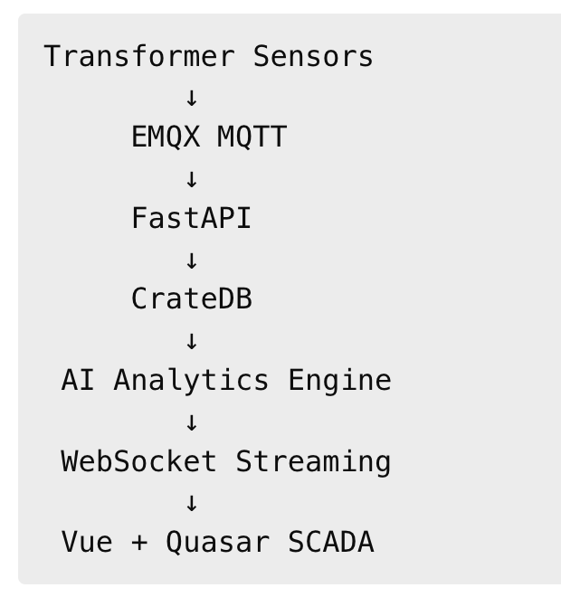

Operational Use Cases

Utility Operator Monitoring
- Realtime transformer supervision
- Alarm response
- Grid stability analysis

Predictive Maintenance
- Maintenance scheduling
- Failure prevention
- Asset optimization

Smart Grid Operations
- Grid balancing
- Power quality management
- Blackout prevention

Digital Twin Simulation
- What-if scenarios
- Stress testing
- Future state simulation

Enterprise Readiness
The SCADA platform is designed for:
- Large-scale utility environments
- Distributed substations
- Multi-region deployments
- High-availability architectures
- Kubernetes deployments
- Edge computing integration

Future Enhancements

Advanced Features
- 3D transformer visualization
- GIS overlays
- Power flow animation
- Grid topology view
- Blackout propagation map
- AI-assisted operator recommendations
- Reinforcement learning control systems

Conclusion
The SCADA Transformer Dashboard provides a modern industrial-grade operational interface for real-time monitoring, predictive maintenance, AI analytics, and Digital Twin visualization.
By combining CrateDB, EMQX, FastAPI, Vue.js, Quasar, and AI forecasting technologies, the platform enables utility operators to transition toward intelligent Smart Grid operations and predictive infrastructure management.
Napravio sam kompletan SCADA Transformer Dashboard dokument za web aplikaciju, uključujući:
- sve senzore koje smo definirali
- realtime SCADA vizualizaciju
- AI analytics i predictive maintenance
- Digital Twin prikaz
- alarm management
- oil & gas diagnostics
- transformer health monitoring
- enterprise arhitekturu
- Vue.js + Quasar frontend koncept
Dokument je pripremljen kao profesionalni opis web aplikacije za razvojni i prodajni tim.

